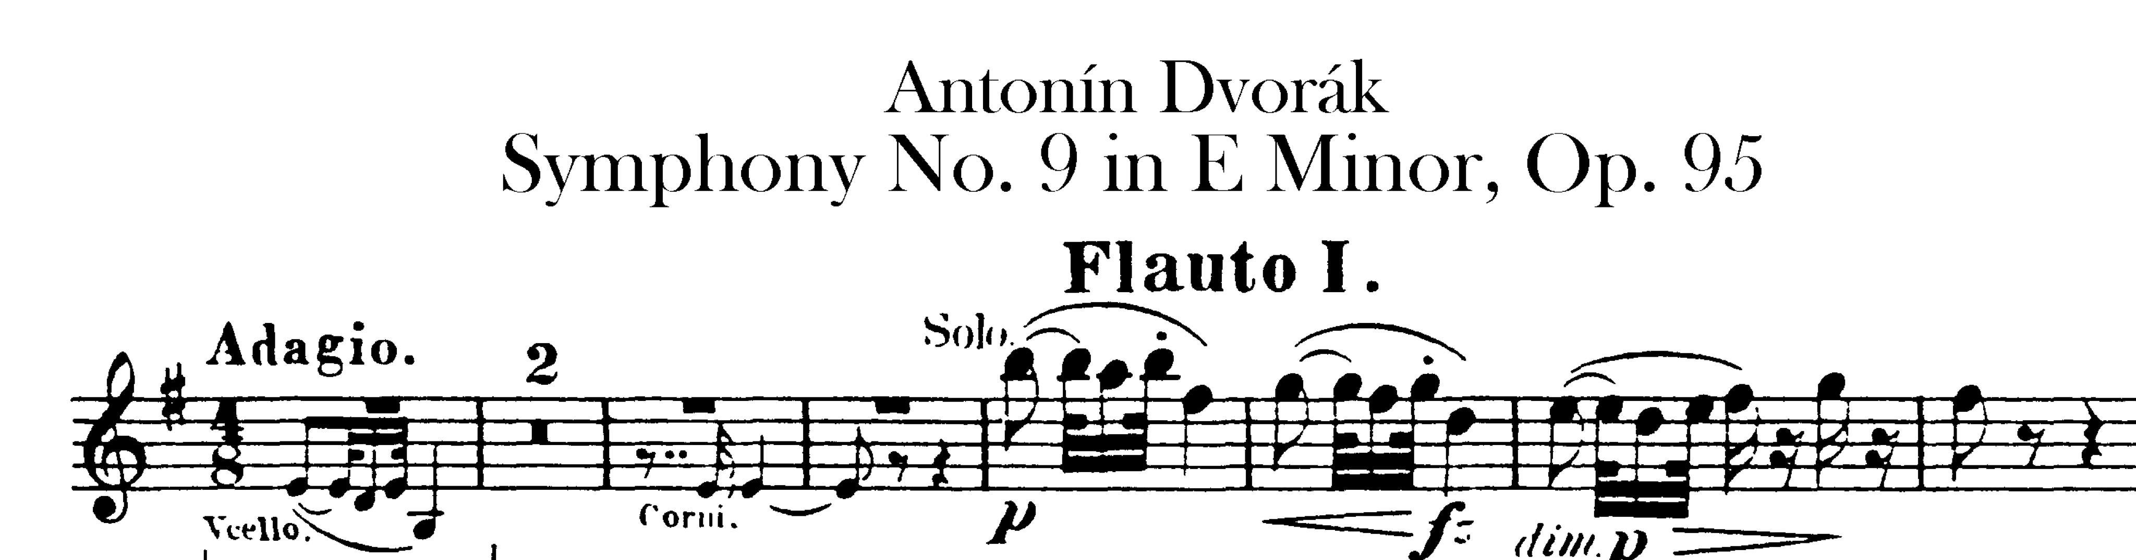

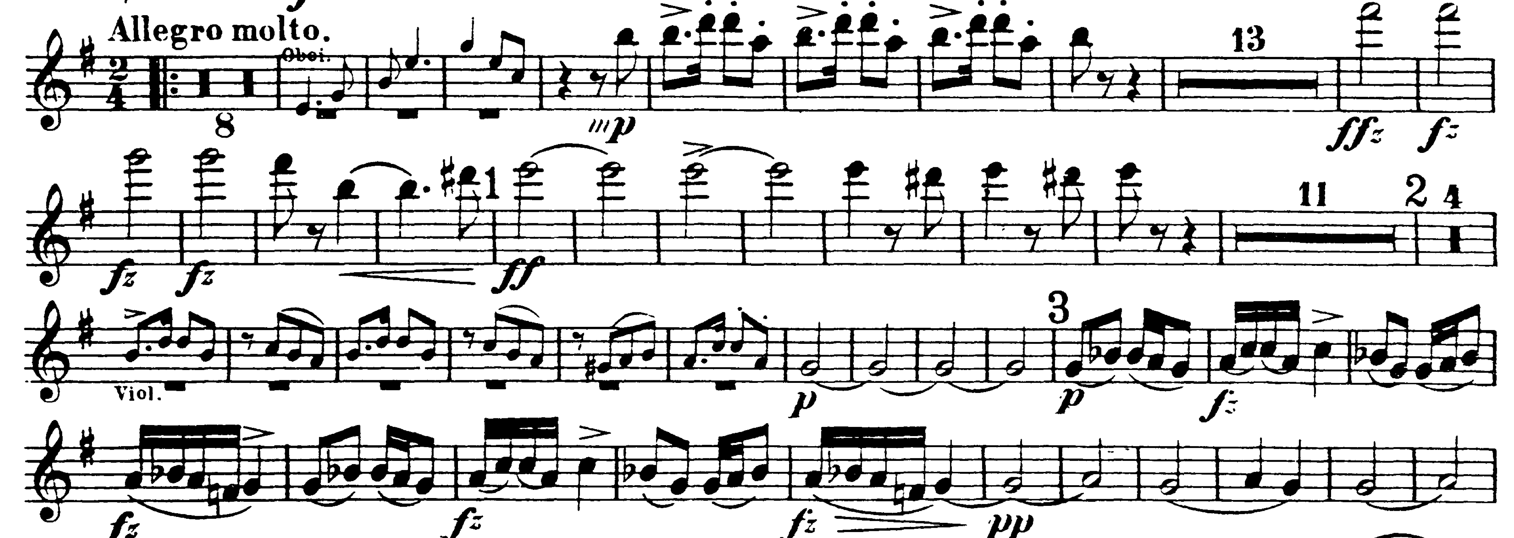

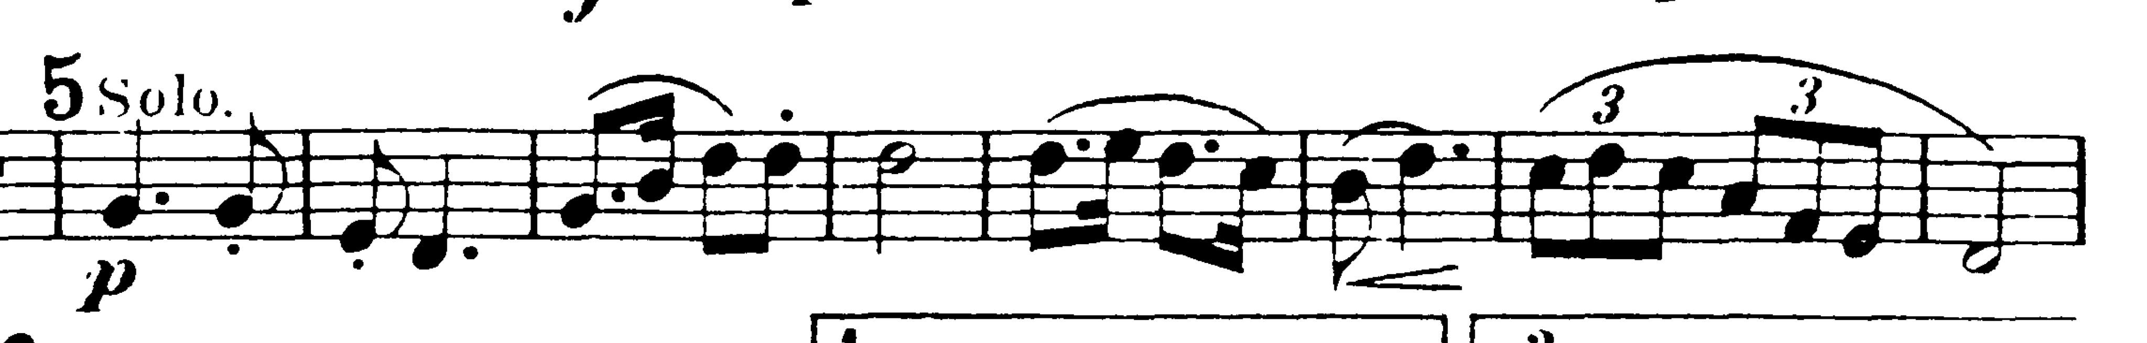

MVT II

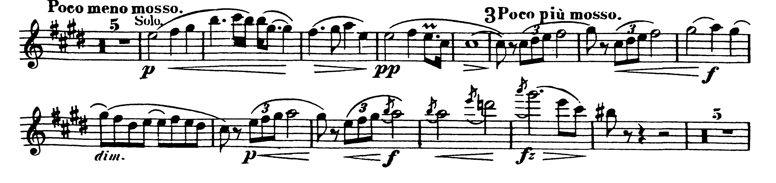

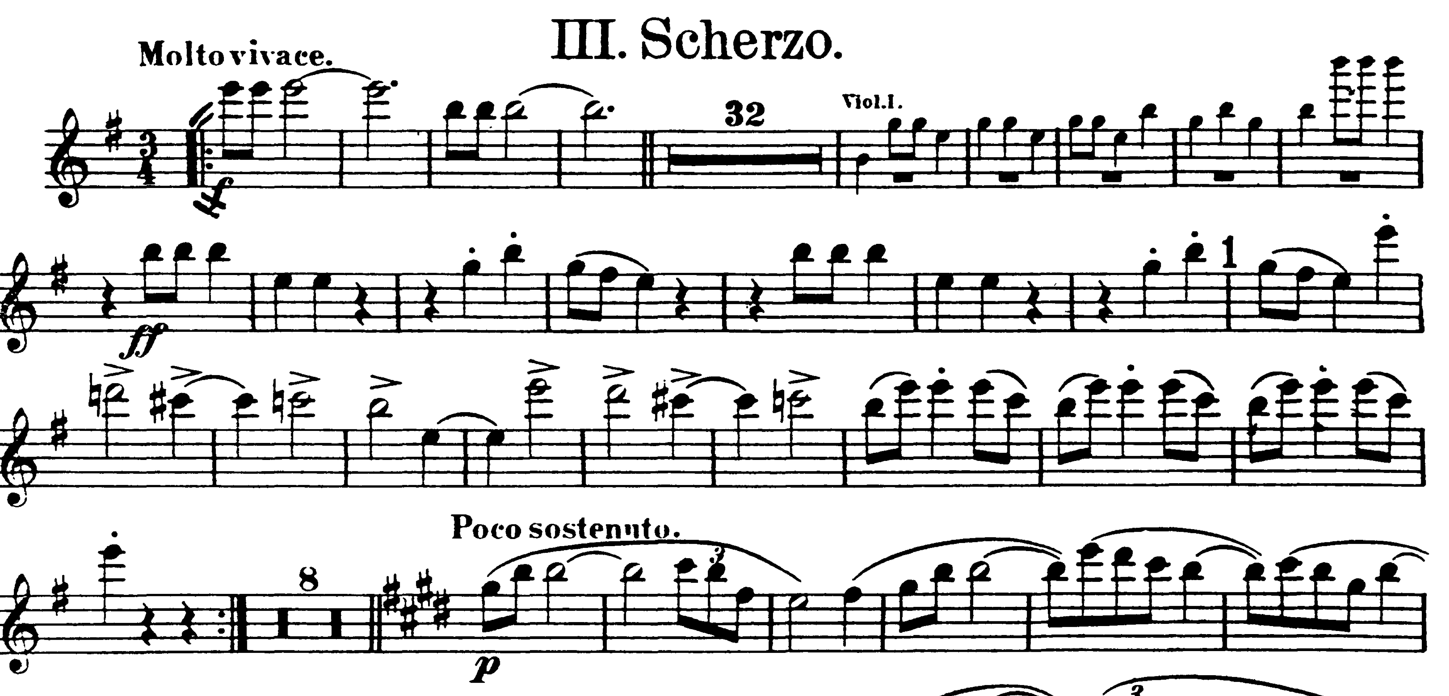

Stop 9 before Poco sostenunto

Beethoven V Mvt. I- start at meas 71

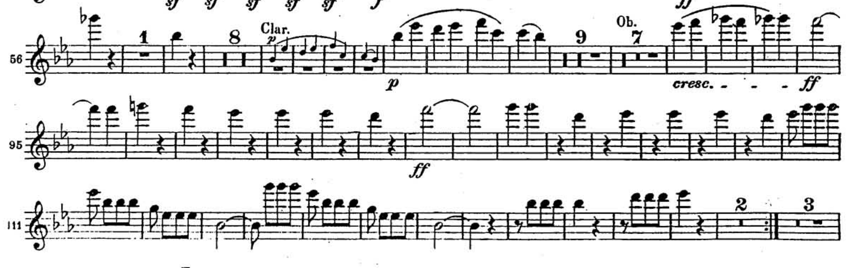

Mvt IV. Start at Tempo I and play to end of excerpt

