Fall 2019 Exhibition Schedule
Florida International University
Miami Beach Urban Studios
420 Lincoln Road, Suite 440
Miami Beach, FL 33139
305-535-1464

http://carta.fiu.edu/mbus/events-calendar/

Main Gallery
420 Lincoln Road, Suite 440
Miami Beach, FL 33139

David Chang – Landscapes
September 16, 2019-October 7, 2019

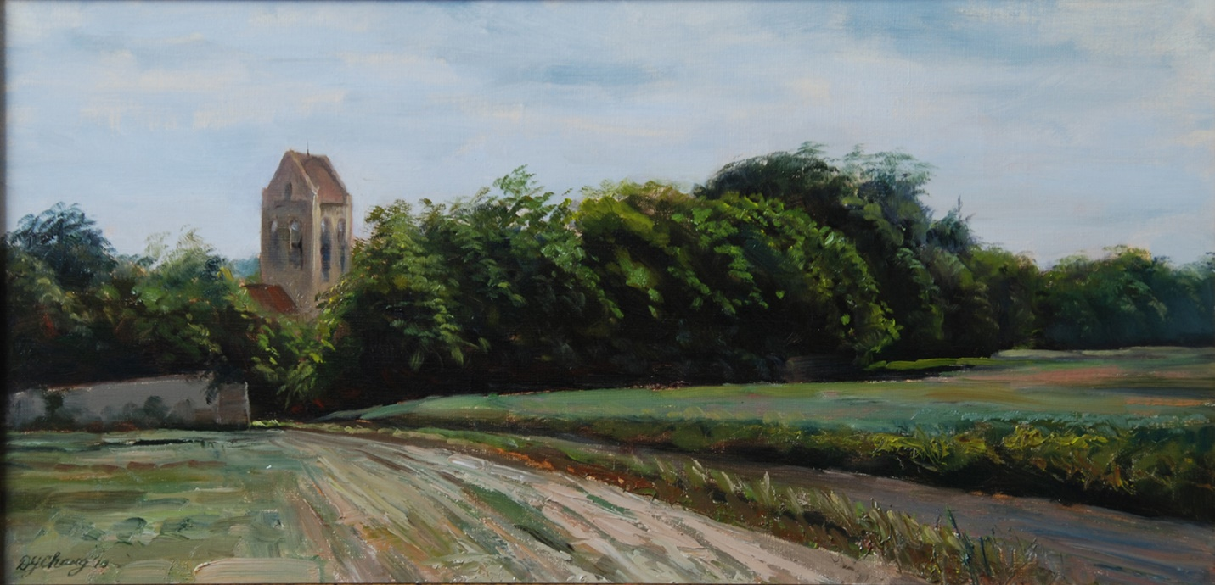
David Chang, Village Church, Oil on Linen

Clive King – Intuitive Drawing
Exhibition Run: October 13, 2019 – November 8, 2019

BFA Thesis Exhibition
Run Date: November 18 - January 1, 2020

Washington Gallery
1618 Washington Avenue
Miami Beach, 33139

Anonymous Women: Domestic Disasters – Photography by Patty Carol Exhibition
Run Date: September 15, 2019 - November 8, 2019

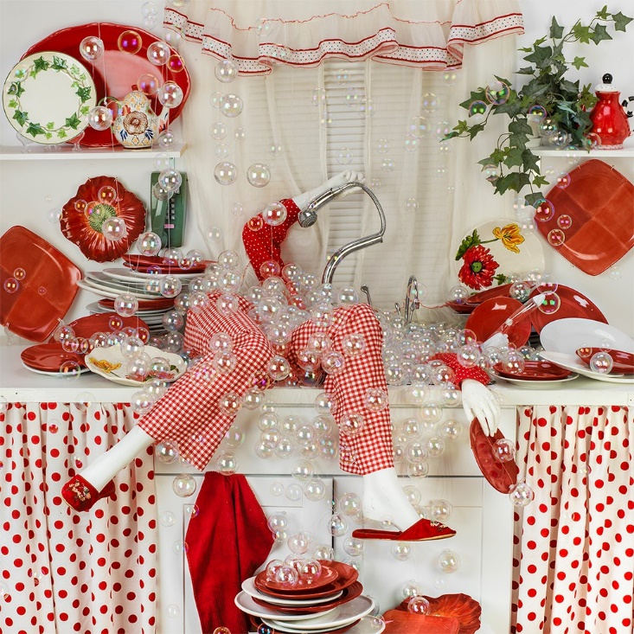
Patty Carol, Dished, Archival Digital Print

Bauhaus Exchange Student Exhibition
November 18, 2019 – January 1, 2020

Curatorial Practice Gallery
420 Lincoln Road
Miami Beach, FL 33139

In the Evening: Photography by Dennis Cuadardo
August 12, 2019 – September 6, 2019

MFA Exhibition by Brandi Long
September 16 – November 8, 2019

Bad Rep(utation) Thesis Exhibition by MFA Candidate Belaxis Buil
November 18, 2019 – January 1, 2020
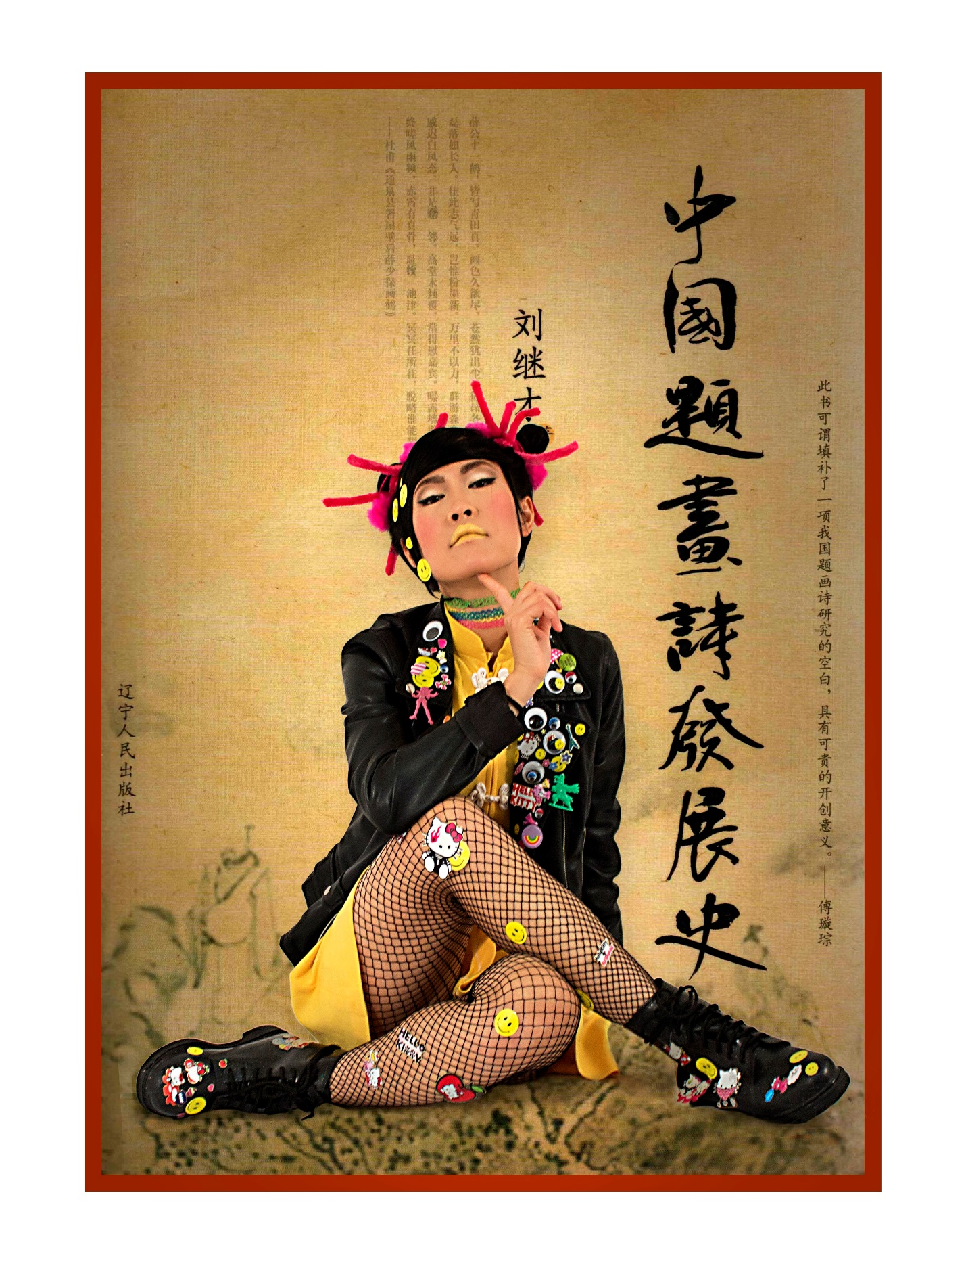
Nuria Currasco, Huchi Chiu (Vowei China), 2018, Fashion & Photography

