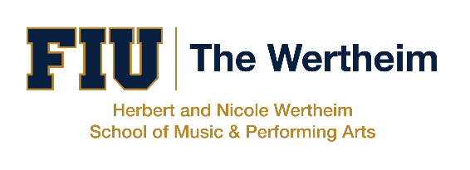

Title

Featured Artists

Friday, October 6, 2023
7:30PM

Wertheim Concert Hall
Herbert and Nicole Wertheim Performing Arts Center

PROGRAM

ENSEMBLE NAME
Ensemble Director

THANK YOU TO OUR SPONSORS
With the support of the Miami-Dade County Department of Cultural Affairs and the Cultural Affairs Council, the Miami-Dade County Mayor and Board of County Commissioners and the College of Communication, Architecture, + The Arts.

Florida International University has been fully and continuously accredited
by the National Association of Schools of Music since 1996.
- An All Steinway School -

Karen S. F. Veloz, Ph.D., Director
FIU Herbert and Nicole Wertheim School of Music and Performing Arts
10910 SW 17th St., Miami, FL 33199
music.fiu.edu | (305) 348 – 2896 | music@fiu.edu

The Herbert and Nicole Wertheim School of Music & Performing Arts
welcomes your support to our music student scholarship program.
More at music.fiu.edu/giving.

Flash photography is not permitted during the performance.
If you must leave during the performance, please do so at the end of a work out of respect for the performers and other audience members.

Subscribe to our mailing list at music.fiu.edu/concerts
(305) 348-0496 | musictix@fiu.edu

